

4CS017 –

Internet Software Architecture

ASSESSMENT – REPORT

**Individual Assessment Topic: Weather App Prototype 1**

**Student Name:** Rohit Ghimire

**Student ID:** 2408291

**Assignment Due Date:** 4th January, 2024

**Assignment Submission Date:** 3rd January,2024

**Module Leader:** Bishal Khadka

Contents

Acknowledgement 2

Introduction 3

Strength 3

Weaknesses 4

# Acknowledgement

I would like to thank our Module Leader MR. Bishal Khadka and Herald College to lead our studies by providing knowledge and skill required for this assignment of 1st Prototype of Weather App. And also a huge thank to Aagya Sharma for her guidance and assessing us in this prototype

# 

# Introduction

This is the assignment of Internet Software Architecture of creating a Weather App (Protoype1) using HTML, CSS and JS designed by Rohit Ghimire. (2408291) The default city assigned to me is Haridwar. It shows the weather description, Temperature, Humidity and search box where you can search the place to find their Temperature and other physical parameters. Below is the picture of my weather app, the first prototype

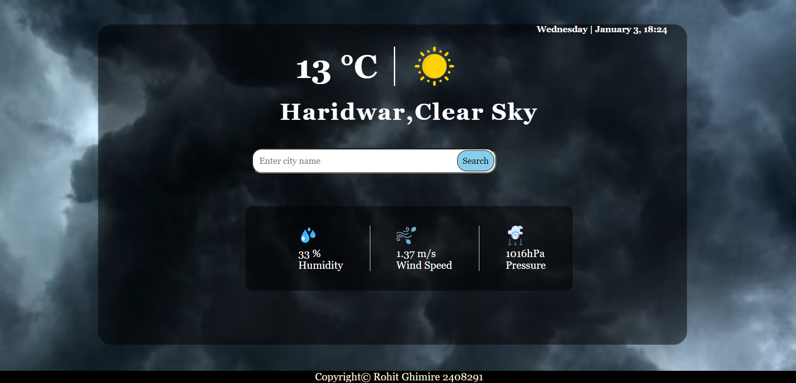

# Strength

The strength of Weather app are as follows:

* Use of HTML, CSS & JavaScript.:

The application is made from HTML and CSS and the using API the weather is extracted and use JS properties like objects and events to handle the events

* Weather of Present Time:

By fetching, Open Weather Api the current temperature, real time of any location is able to see, and other physical quantity are seen without the use of calculating and measuring them without device

* We could get result of different location which is useful since we could have information of the

# Weaknesses

The weaknesses I would like to highlight first of all is, it is not made for mobile i.e., it is not responsive design.

* I have connected the icon of weather in GitHub which is linked through JS and due to this it takes a little extra time to load.
* This project does not contain weekly temperature